South Shore Dry Dock Marine

Full Stocking Marine Supply Store

Scituate Harbor, Mass

(Cole Parkway Side)

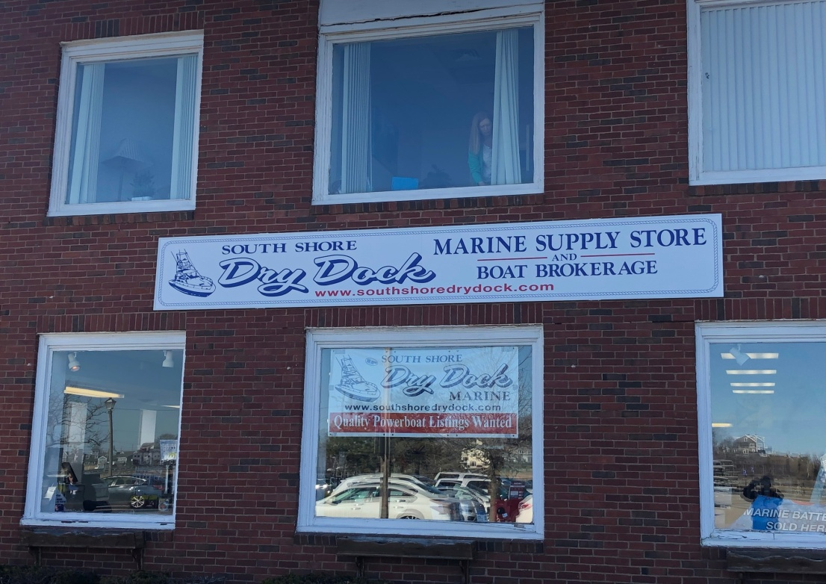

* Anchors, Anti Fouling Paint, Batteries, Bilge Pumps. Canyon Coolers,
* Cleaning Supplies ,Costa Sunglasses & Apparel, DEEP Clothing Apparel,
* Dock Lines, Epifanes Varnish, Electrical Connections, Fusion Marine Stereos,
* Fenders, Fiberglass, Flare Kits, Fuel Additives, Fuel Line, Filters, Hoses,
* Interlux Paints, Lumitec Lighting, Marine Sanitation, Oil, Propellers,
* Wire, W.O.W. Watersports, West System, Zincs, 3M Products.
* And Much, Much More!!! Next Day Ordering!!!

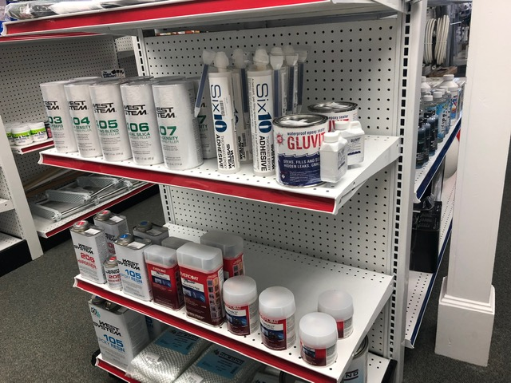 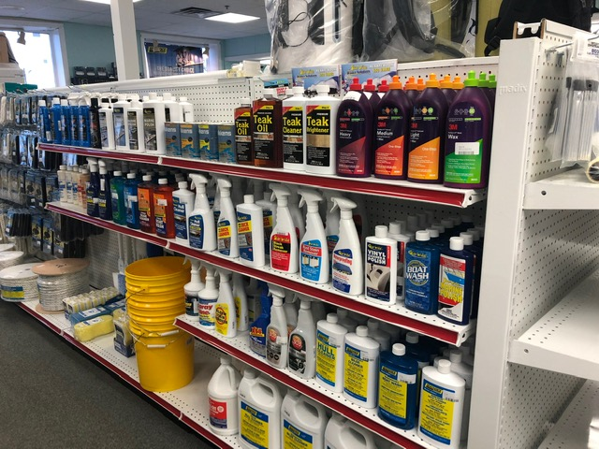

www.southshoredrydock.com

**781-834-9790 or 781-378-0173**